Barnet Hospital,
Wellhouse Lane,
Barnet,
EN5 3DJ

Tel: 020 8216 4600
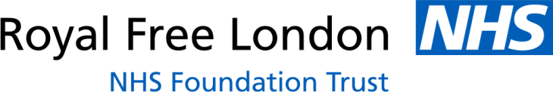

Dear Charmaine,

I would just like to take this opportunity to thank you properly for the wonderful donation of pyjamas we received from ‘Children’s Hospital Pyjamas’. We were amazed at how many pyjamas we received and were very grateful to everyone that took the time to donate them.

As we are a relatively small children’s ward we rely solely on donations so having these pyjamas were and still are hugely beneficial to the children we see on the ward. As we have an extensive day surgery list and many children who have to stay either overnight or for long periods of time depending on their illness we were able to provide comfy pyjamas to those who had either forgotten theirs or did not want to use our hospital gowns. This is very important that the children feel comfortable in the hospital environment and also gives them a sense of normality whilst being here.

Once again thank you so much for considering our hospital as one of the places you sent the donations to. It’s hugely appreciated by everyone on Galaxy Ward.

Kind regards,

Chloe Ham
Play Specialist
Barnet Hospital – Galaxy Ward

